Air Suspension Control Function for SUMA and Warning Messages – CGEA1.3

Functional Description

This STSS is used when the vehicle Air Suspension feature is implemented by a SUMA module instead of a VDM (Vehicle Dynamics Module).
Currently, this only applies to U611.
(Full name of module is the SUMA_RLM which stands for “Suspension Module A”. The module ID currently is $7D3 on HS2.)
This STSS is mutually exclusive with Air Suspension Control Function and Warning Messages CGEA1.3_v1.0.doc which is used when there is a VDM and is currently implemented on 2016 V363C and 2016.5 V363E.

This STSS handles 3 settings for the Air Suspension feature, which provides the choice to disable/enable the rear air suspension system for service and to disable/enable Vehicle Kneel and to disable/enable Cargo Loading Mode via the settings menu. (“Vehicle Kneel” is also known as Ride Height Kneel Ingress/Egress, and also known as “Auto Entry/Exit Height”, which will lower the height of vehicle when turning ignition from RUN to OFF.

The Instrument Cluster uses the Personalization signals for the Message Center function to enable/disable these feature in the SUMA module.

This STSS also supports 4 warning messages for Air Suspension. The warning messages are used to convey to the operator that the air suspension is on due to speed or faulty. The IPC displays warning “air suspension on due to vehicle speed”, “air suspension fault”, “Suspension Fault Drive Below 30 MPH”, or “Suspension Fault Drive below 45 km/h” as per the state of the AirSuspMsgTxt_D_Rq signal. Per agreement with the Suspension Group the “Suspension Fault Drive Below 30 MPH” and “Suspension Fault Drive below 45 km/h” are NR and shall only be shown at or above 45 km/h to allow the operator access to the message center at lower speeds.

Verify through PDL if a program is equipped with air suspension via the SUMA and if so verify with feature owner as to whether this STSS is required.

The SUMA remembers the state of the air suspension feature over each key cycle and controls the initial battery connect default state.

Starting in MY2019 with U625/U611 the Settings are migrating from the cluster to Center stack. This STSS supports displaying settings in the cluster or configuring the cluster settings off if they are displayed in the Center stack.

The customer uses the message center switches and display to enable and/or change the Air Suspension settings when displayed in the message center.

Interfaces

Interface Context Diagram (I/O Block Diagram)
Figure 1 Air Suspension for SUMA Context Diagram
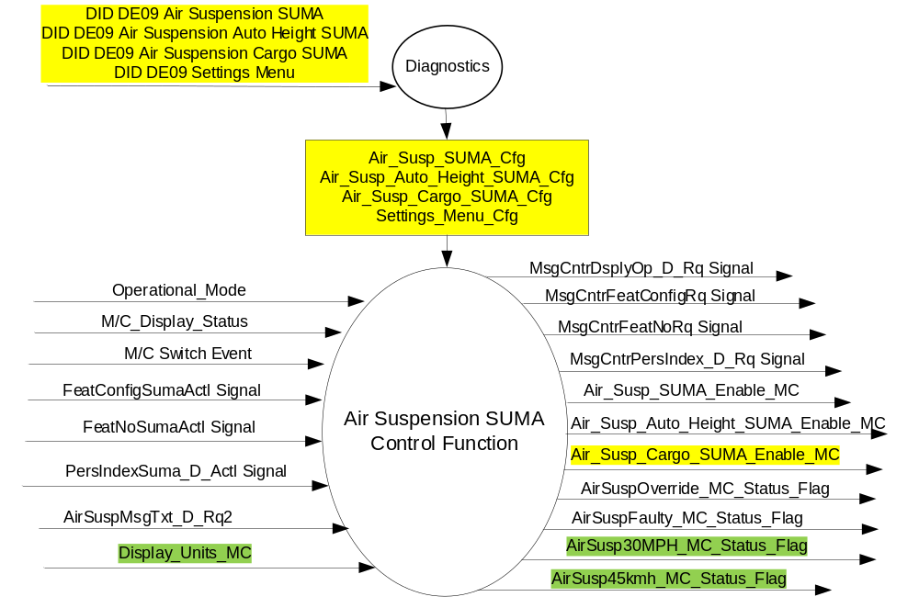

Inputs

- INTERNAL:
- Operational_Mode
- M/C Switch Event
- Air_Susp_SUMA_Cfg
- Air_Susp_Auto_Height_SUMA_Cfg
- Air_Susp_Cargo_SUMA_Cfg
- Settings_Menu_Cfg
- M/C_Display_Status
- Display_Units_MC
- MUX message on the CAN Bus

- FeatConfigSumaActl Signal
Signal Name | Size (bits) | Detail | Units | Res. | Offset | State Encoded | Min | Max
FeatConfigSumaActl | 16 | - | Undefined | 1 | 0 |  | 0  (0x0) | 65535  (0xFFFF)
- FeatNoSuma_No_Actl Signal
Signal Name | Size (bits) | Detail | Units | Res. | Offset | State Encoded | Min | Max
FeatNoSumaActl | 16 | - | Number | 1 | 0 |  | 0  (0x0) | 65535  (0xFFFF)

- PersIndexSuma_D_Actl Signal
Signal Name | Size (bits) | Detail | Units | Res. | Offset | State Encoded | Min | Max
PersIndexSuma_D_Actl | 3 |  | SED | 1 | 0 |  | 0  (0x0) | 7  (0x7)
 |  | PERS_1 |  |  |  | 0 (0x0)
 |  | PERS_2 |  |  |  | 1 (0x1)
 |  | PERS_3 |  |  |  | 2 (0x2)
 |  | PERS_4 |  |  |  | 3 (0x3)
 |  | Vehicle |  |  |  | 4 (0x4)
 |  | Unused |  |  |  | 5(0x5)
 |  | Unused |  |  |  | 6 (0x6)
 |  | Unused |  |  |  | 7 (0x7)

- AirSuspMsgTxt_D_Rq Signal
Signal Name | Size  (bits) | Detail | Units | Res. | Offset | State  Encoded | Min | Max
AirSuspMsgTxt_D_Rq2 | 2 |  | SED | 1 | 0 |  | 0 (0x0) | 3 (0x3)
 |  | No Message |  |  |  | 0x0
 |  | Override |  |  |  | 0x1
 |  | Faulty |  |  |  | 0x2
 |  | FaultyNotClearable |  |  |  | 0x3

Outputs
- Air_Susp_SUMA_Enable_MC
- Air_Susp_Auto_Height_SUMA_Enable_MC
- Air_Susp_Cargo_SUMA_Enable_MC
- AirSuspOverride_MC_Status_Flag
- AirSuspFaulty_MC_Status_Flag
- AirSusp30MPH_MC_Status_Flag
- AirSusp45kmh_MC_Status_Flag
- MUX message on the CAN Bus

- MsgCntrDsplyOp_D_Rq Signal
Signal Name | Size (bits) | Detail | Units | Res. | Offset | State Encoded | Min | Max
MsgCntrDsplyOp_D_Rq | 3 |  | SED | 1 | 0 |  | 0  (0x0) | 7  (0x7)
 |  | NULL |  |  |  | 0 (0x0)
 |  | QUERY |  |  |  | 1 (0x1)
 |  | SET |  |  |  | 2 (0x2)
 |  | UPLOAD |  |  |  | 3 (0x3)
 |  | RESTORE |  |  |  | 4 (0x4)
 |  | COPY |  |  |  | 5(0x5)
 |  | Not used |  |  |  | 6 (0x6)
 |  | Not Used |  |  |  | 7 (0x7)
.
- MsgCntrFeatConfigRq Signal
Signal Name | Size (bits) | Detail | Units | Res. | Offset | State Encoded | Min | Max
MsgCntrFeatConfigRq | 16 |  | Undefined | 1 | 0 |  | 0  (0x0) | 65535  (0xFFFF)

- MsgCntrFeatNoRq Signal
Signal Name | Size (bits) | Detail | Units | Res. | Offset | State Encoded | Min | Max
MsgCntrFeatNoRq | 16 |  | Number | 1 | 0 |  | 0  (0x0) | 65535  (0xFFFF)

- MsgCntrPersIndex_D_Rq
Signal Name | Size (bits) | Detail | Units | Res. | Offset | State Encoded | Min | Max
MsgCntrPersIndex_D_Rq | 3 |  | SED | 1 | 0 |  | 0  (0x0) | 7  (0x7)
 |  | PERS_1 |  |  |  | 0 (0x0)
 |  | PERS_2 |  |  |  | 1 (0x1)
 |  | PERS_3 |  |  |  | 2 (0x2)
 |  | PERS_4 |  |  |  | 3 (0x3)
 |  | Vehicle |  |  |  | 4 (0x4)
 |  | Not Used |  |  |  | 5 (0x5)
 |  | Not Used |  |  |  | 6 (0x6)
 |  | Not Used |  |  |  | 7 (0x7)

Function/Performance

Operational Modes

Mode | Differentiating Vehicle Conditions
Sleep Mode | Air Suspension Control Function / Text Messages Disabled
Limiting Mode | Air Suspension Control Function / Text Messages Disabled
Normal Mode | Air Suspension Control Function / Text Messages Enabled / Disabled
Crank Mode | Air Suspension Control Function / Text Messages Enabled / Disabled

Voltage Levels

Refer to the Cluster Features table located in the Operational Modes and Voltage Range Strategies Section in this SPSS.

Human-Machine Interface

Visual

Indicator Graphics / Display Format
For program specific display, refer to “<Program> Cluster Menu Structure.xls”.

Example Graphics (with just “Air Suspension SUMA” DE09 configured on):
Level 2 | Level 3
Vehicle Settings > | # Air Suspension Service

Example Graphics (with both “Air Suspension SUMA” DE09 configured on and “Air Suspension Auto Height SUMA” DE09 configured on): (Note “Air Suspension Service” is NOT grouped with “Easy Access Height” or “Cargo Loading”)
Level 2 | Level 3
Vehicle Settings > | # Air Suspension Service
Easy Entry/Exit > | # Easy Access Height

Example Graphics (with “Air Suspension SUMA” DE09 configured on and “Air Suspension Auto Height SUMA” DE09 configured on) and “Air Suspension Cargo SUMA” DE09 configured on: (Note “Air Suspension Service” is NOT grouped with “Easy Access Height” or “Cargo Loading”)
Level 2 | Level 3
Vehicle Settings > | # Air Suspension Service
Easy Entry/Exit > | # Cargo Loading  # Easy Access Height

Setting Menu Grey out Rules: (Note, HMI Menu structure is master if different. This is included here to make sure requirements are not missed, and to prompt a Q&A if menu structure is different)
- “Cargo Loading” and “Easy Access Height” settings shall grey out when “Air Suspension Service” is turned on.
- When “Air Suspension Service” is turned off, “Cargo Loading” and “Easy Access Height” settings shall not be greyed out.
- When “Cargo Loading” and “Easy Access Height” settings are greyed out due to “Air Suspension Service” being on and the customer attempts to turn them on/off, shall get Confirmation Message C84.

Indicator Color Coordinates

Reference section COLOR & ILLUMINATION REQUIREMENTS (GRAPHICS)

Indicator Characteristics

Refer to Message Center X Display_Y Button Interface Section, where X and Y are appropriate values in this document.

Audio

See Table 1.9 for chimes associated with this feature.

Switch Control Logic

Consumer access to the Air Suspension Control Configuration shall be as specified in the message center basic functionality display as specified in Message Center X Display_Y Button Interface Section, where X and Y are appropriate values in this document.

System Accuracy

Within a 100msec of receiving a message that results in a change of state the cluster will update the display to the proper status.

Operation: Performance and Functional

Subsystem Algorithm Flowchart / State Diagram

Figure 2 Air Suspension Diagnostic Flowcharts
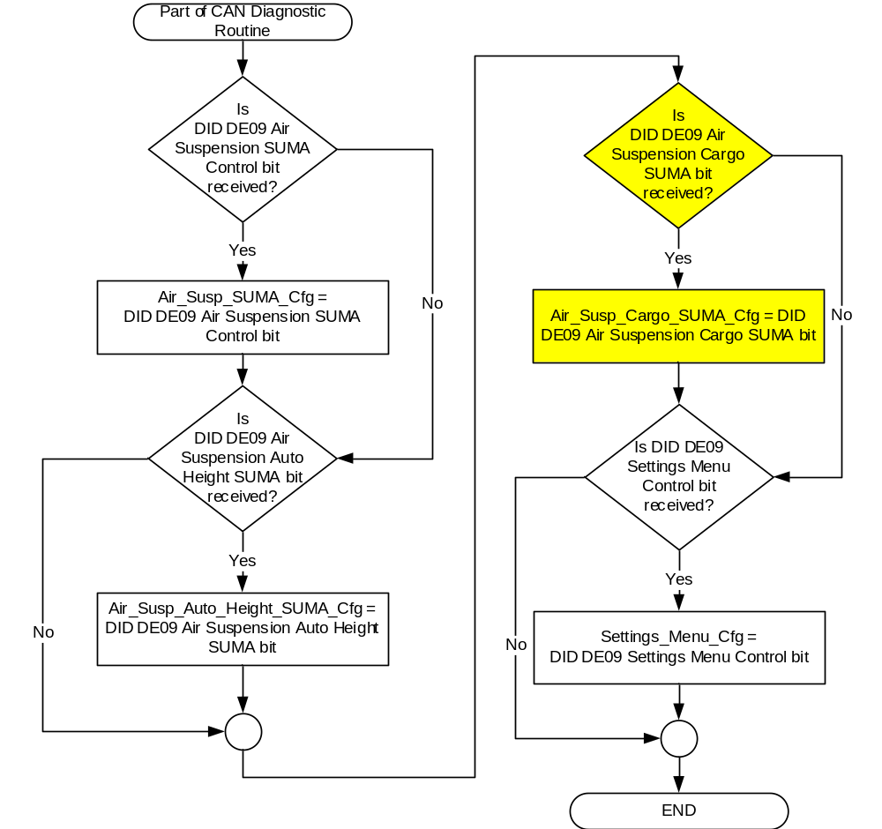

Figure 3: Air Suspension input SET request Flowcharts

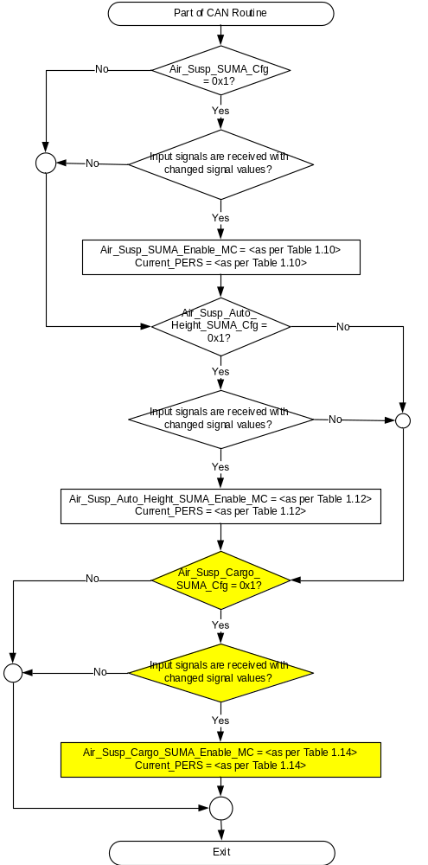

Figure 4: Air Suspension output SET request Flowcharts

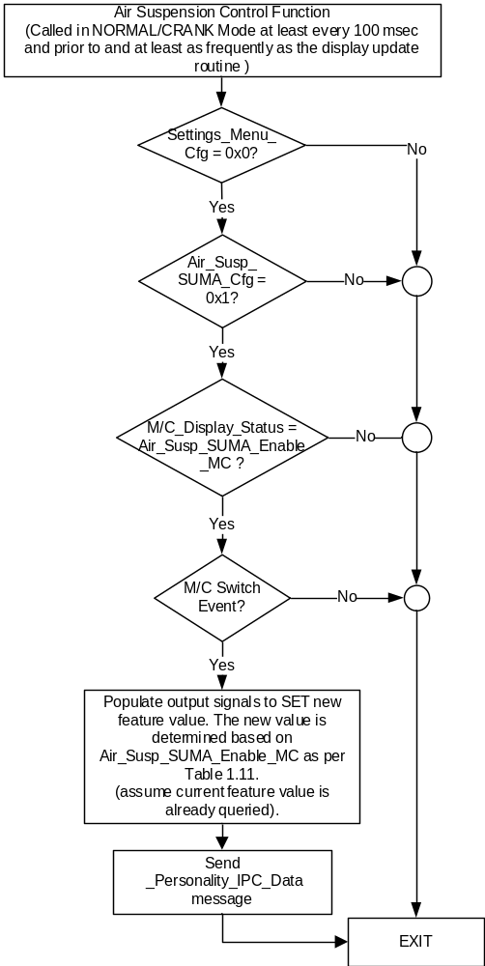

NOTE: In the Air Suspension Control Function Flowchart, the definition of "M/C Switch Event" is defined in Message Center X Display_Y Button Interface Section, where X and Y are appropriate values in this document.

Figure 5: Air Suspension Auto Height output SET request Flowcharts

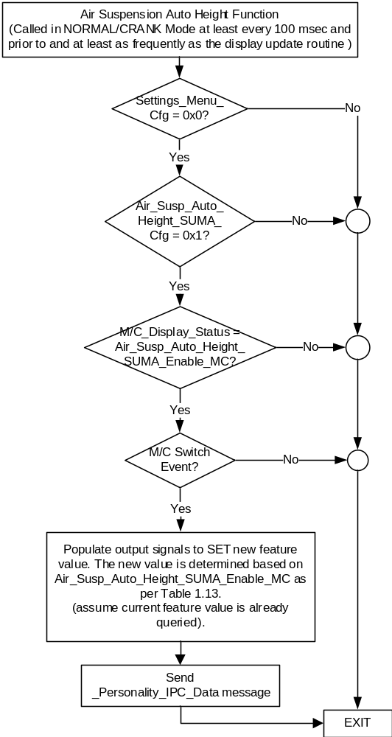

NOTE: In the Air Suspension Auto Height Flowchart, the definition of "M/C Switch Event" is defined in Message Center X Display_Y Button Interface Section, where X and Y are appropriate values in this document.

Figure 6: Air Suspension Cargo output SET request Flowcharts

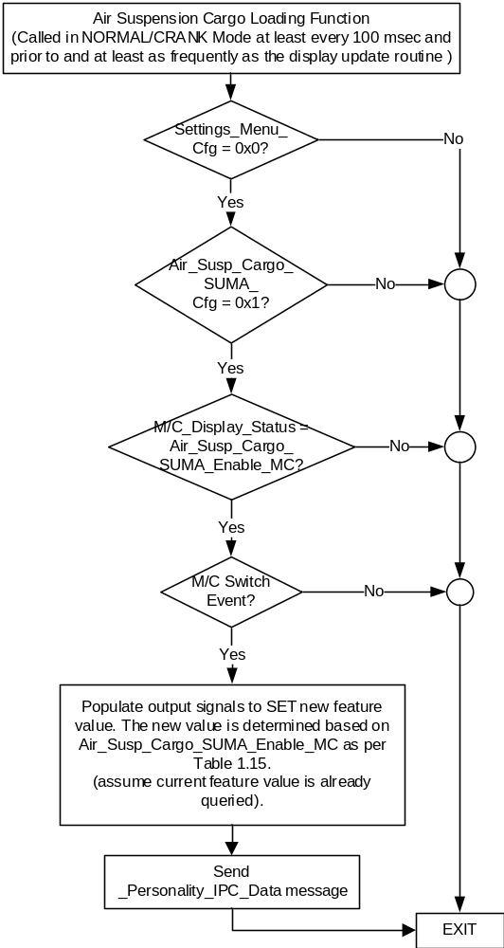

NOTE: In the Air Suspension Cargo Flowchart, the definition of "M/C Switch Event" is defined in Message Center X Display_Y Button Interface Section, where X and Y are appropriate values in this document.

- State Matrix for Air Suspension Warnings
Operational  _Mode | Air_Susp_  SUMA_Cfg | Display  _Units  _MC | AirSuspMsgTxt  _D_Rq2  Signal | AirSuspOverride  _MC_Status  _Flag | AirSuspFaulty  _MC_Status  _Flag | AirSusp30MPH_  MC_Status_Flag | AirSusp45kmh_  MC_Status_Flag
Normal or  Crank | 0x1 | X | Override (0x1) | Active | Inactive | Inactive | Inactive
Normal or  Crank | 0x1 | X | Faulty (0x2) | Inactive | Active | Inactive | Inactive
Normal or  Crank | 0x1 | English  (0x0 I 0x1) | FaultyNotClearable (0x3) | Inactive | Inactive | Active | Inactive
Normal or  Crank | 0x1 | Metric (0x2 I 0x3) | FaultyNotClearable (0x3) | Inactive | Inactive | Inactive | Active
Normal or  Crank | 0x1 | X | Missing as per 1.4.1 | Inactive | Active | Inactive | Inactive
All Other Cases |  |  |  | All Other Cases

- MC_Status_Flag to Warning Message ID
AirSuspOverride  _MC_Status_Flag | AirSuspFaulty  _MC_Status_Flag | AirSusp30MPH_  MC_Status_Flag | AirSusp45kmh_  MC_Status_Flag | MC Warning  Message ID | Warning  Type | Associated  Warning Chime
Active | Inactive | Inactive | Inactive | W3361 | TA | Info
Inactive | Active | Inactive | Inactive | W3360 | SC* | Info
Inactive | Inactive | Active | Inactive | W3362 | NR | Hard
Inactive | Inactive | Inactive | Active | W3363 | NR | Hard

Operation Description (supports algorithm flowchart /state diagram)

- Air_Susp_SUMA_Enable_MC State Assignment
FeatNoSumaActl | FeatConfigSumaActl | Air_Susp_SUMA_Enable_MC | Current_PERS ⁽³⁾
0x0B03 ⁽¹⁾ | Disable  (0x00) | Disable  (0x0) | 0x0 - 0x4
0x0B03 ⁽¹⁾ | Enable  (0x01) | Enable  (0x1) | 0x0 - 0x4
0x0B03 ⁽¹⁾ | Other ⁽²⁾ | Error  (0x2) | Last Known
Missing per Section 1.4.1 ⁽²⁾ |  | Error  (0x2) | Last Known
⁽¹⁾ Air Suspension Enable Feature Number. Reference is Feat Num table in “Vehicle Personalization FS”
⁽²⁾ Message Response is Faulted
⁽³⁾ Equal to the received “PersIndex<--->” signal value . When faulted Keep last known value.

- Message Center Display and MC Air Suspension Request Messages

based upon Air_Susp_SUMA_Enable_MC
Air_Susp_  SUMA_  Enable_MC | Display Menu | 5-Button Switch Selection Event | MsgCntrDsplyOp_D_Rq  Signal | MsgCntrFeatNoRq  Signal | MsgCntrFeatConfigRq  Signal | MsgCntrPersIndex_  D_Rq  Signal
Off  (0x0) |  Off   On | Up/Down + OK (Select On) | SET (0x2) | 0x0B03 | 0x01 (Enabled) | Current_PERS
On  (0x1) |  Off   On | Up/Down + OK (Select Off) | SET (0x2) | 0x0B03 | 0x00 (Disabled) | Current_PERS
Error  (0x2) |  Off   On | Up/Down + OK (Select Off or On) | SET (0x2) | 0x0B03 | 0x00 (if Off is selected)  0x01 (if On is selected) | Current_PERS

- Air_Susp_Auto_Height_SUMA_Enable_MC State Assignment
FeatNoSumaActl | FeatConfigSumaActl | Air_Susp_Auto_Height_SUMA_  Enable_MC | Current_PERS ⁽³⁾
0x0B04 ⁽¹⁾ | Disable  (0x00) | Disable  (0x0) | 0x0 - 0x4
0x0B04 ⁽¹⁾ | Enable  (0x01) | Enable  (0x1) | 0x0 - 0x4
0x0B04 ⁽¹⁾ | Other ⁽²⁾ | Error  (0x2) | Last Known
Missing per Section 1.4.1 ⁽²⁾ |  | Error  (0x2) | Last Known
⁽¹⁾ Air Suspension Auto Height Feature Number. Reference is Feat Num table in “Vehicle Personalization FS”
⁽²⁾ Message Response is Faulted
⁽³⁾ Equal to the received “PersIndex<--->” signal value . When faulted Keep last known value.

- Message Center Display and MC Air Suspension Auto Height Request Messages based upon Air_Susp_Auto_Height_SUMA_Enable_MC
Air_Susp_  Auto_Height_SUMA_  Enable_MC | Display Menu | 5-Button Switch Selection Event | MsgCntrDsplyOp_D_Rq  Signal | MsgCntrFeatNoRq  Signal | MsgCntrFeatConfigRq  Signal | MsgCntrPersIndex_D_Rq  Signal
Off  (0x0) |  Off   On | Up/Down + OK (Select On) | SET (0x2) | 0x0B04 | 0x01 (Enabled) | Current_PERS
On  (0x1) |  Off   On | Up/Down + OK (Select Off) | SET (0x2) | 0x0B04 | 0x00 (Disabled) | Current_PERS
Error  (0x2) |  Off   On | Up/Down + OK (Select Off or On) | SET (0x2) | 0x0B04 | 0x00 (if Off is selected)  0x01 (if On is selected) | Current_PERS

- Air_Susp_Cargo_SUMA_Enable_MC State Assignment
FeatNoSumaActl | FeatConfigSumaActl | Air_Susp_Cargo_SUMA_  Enable_MC | Current_PERS ⁽³⁾
0x0B05 ⁽¹⁾ | Disable  (0x00) | Disable  (0x0) | 0x0 - 0x4
0x0B05 ⁽¹⁾ | Enable  (0x01) | Enable  (0x1) | 0x0 - 0x4
0x0B05 ⁽¹⁾ | Other ⁽²⁾ | Error  (0x2) | Last Known
Missing per Section 1.4.1 ⁽²⁾ |  | Error  (0x2) | Last Known
⁽¹⁾ Air Suspension Cargo Feature Number. Reference is Feat Num table in “Vehicle Personalization FS”
⁽²⁾ Message Response is Faulted
⁽³⁾ Equal to the received “PersIndex<--->” signal value . When faulted Keep last known value.

- Message Center Display and MC Air Suspension Cargo Request Messages based upon Air_Susp_Cargo_SUMA_Enable_MC
Air_Susp_  Cargo_SUMA_  Enable_MC | Display Menu | 5-Button Switch Selection Event | MsgCntrDsplyOp_D_Rq  Signal | MsgCntrFeatNoRq  Signal | MsgCntrFeatConfigRq  Signal | MsgCntrPersIndex_D_Rq  Signal
Off  (0x0) |  Off   On | Up/Down + OK (Select On) | SET (0x2) | 0x0B05 | 0x01 (Enabled) | Current_PERS
On  (0x1) |  Off   On | Up/Down + OK (Select Off) | SET (0x2) | 0x0B05 | 0x00 (Disabled) | Current_PERS
Error  (0x2) |  Off   On | Up/Down + OK (Select Off or On) | SET (0x2) | 0x0B05 | 0x00 (if Off is selected)  0x01 (if On is selected) | Current_PERS

- Personalization Features for Air Suspension
Feature Name | Feature Num | Cfg Num | Cfg Value
Air Suspension | 0x0B03 | 0x00 | Disabled
Air Suspension | 0x0B03 | 0x01 | Enable
Auto Entry/Exit Height | 0x0B04 | 0x00 | Disabled
Auto Entry/Exit Height | 0x0B04 | 0x01 | Enable
Cargo Mode | 0x0B05 | 0x00 | Disabled
Cargo Mode | 0x0B05 | 0x01 | Enable

Function Safety Classification (EMC)

Class B

Memory Storage

Parameter Name | Description | Value at  Battery Connect | Value at  Module Wake-up
Air_Susp_SUMA_Enable_MC | Output displayed in the M/C | Disabled (0x0) | Do Not Init
Air_Susp_Auto_Height_SUMA_Enable_MC | Output displayed in the M/C | Disabled (0x0) | Do Not Init
Air_Susp_Cargo_SUMA_Enable_MC | Output displayed in the M/C | Disabled (0x0) | Do Not Init
AirSuspOverride_MC_Status_Flag | State variable used by M/C Warning Arbitrator | Inactive | Inactive
AirSuspFaulty_MC_Status_Flag | State variable used by M/C Warning Arbitrator | Inactive | Inactive
AirSusp30MPH_MC_Status_Flag | State variable used by M/C Warning Arbitrator | Inactive | Inactive
AirSusp45kmh_MC_Status_Flag | State variable used by M/C Warning Arbitrator | Inactive | Inactive
AirSuspMsgTxt_D_Rq2 Signal | CAN Signal received from SUMA | No Message (0x0) | No Message (0x0)
MsgCntrDsplyOp_D_Rq Signal | Output Signal to indicate Request Type. | NULL (0x0) | Do Not Init
MsgCntrFeatNoRq Signal | Output Signal to indicate Feature Number. | (0x0000) | Do Not Init
MsgCntrFeatConfigRq Signal | Output Signal to Specify the desired feature Value. | (0x0000) | Do Not Init
MsgCntrPersIndex_D_Rq Signal | Output Signal to indicate which personality profile is being accessed. | Vehicle (0x4) | Do Not Init
FeatNoSumaActl Signal | Input signal sent from SUMA to indicate Feature Number. | (0x0000) | Do Not Init
FeatConfigSumaActl Signal | Input signal sent from SUMA to indicate current value of the feature setting for the feature that is being set or queried. | (0x0000) | Do Not Init
Air_Susp_SUMA_Cfg | Configures cluster to allow Air Suspension Enable/Disable menu. Set to Disabled at Cluster Supplier Manufacturing Plant. | Use Stored Value | Use Stored Value
Air_Susp_Auto_Height_SUMA_Cfg | Configures cluster to allow Air Suspension Auto Entry/Exit Height Eanble/Disable menu. Set to Disabled at Cluster Supplier Manufacturing Plant. | Use Stored Value | Use Stored Value
Settings_Menu_Cfg | Configures cluster to display items in the Settings menu (Set to “cluster” at cluster supplier manufacturer plant) | Use Stored Value | Use Stored Value
M/C_Display_Status | State Indicator to identify which text is currently being displayed on Message Center display. See * | See * below | See * below
M/C Switch Event | Event that is indicated as per the switch interface for the Message Center. See * | See * below | See * below
Operational_Mode | 4 state indicator for cluster operational mode | Limited | Limited, Normal or Crank

* Refer to Message Center X Display_Y Button Interface Section, where X and Y are appropriate values in this document.

Reconfigurable Telltale

Not Applicable

Prove Out

Not applicable

Message Center Msg

W3360 and W3361

Error Handling

Missing Message Strategy

The signals will be declared missing as per the Diagnostics section of this SPSS.

DTCs states and history will be determined as per the Diagnostics section of this SPSS.

If Air_Susp_SUMA_Cfg = Disabled, the cluster shall never log a missing message for this feature.

Diagnostics

Self Test

None

Engineering Test Mode

Reference section “Dealer / Engineering Test Mode (ETM)”

Part II Performance

Supported Diagnostic Trouble Codes (DTCs)
DTC | Description
C13200 | Lost Communication With Suspension Control Module "A"

DID DExx:
Block  Num | Block Description | Byte(s) | Bits | State: Description | "0" | "1" | Default | Comments/Information
PACKETED BLOCKS
$09 | Option Content (B&A) | * | * | Air Suspension SUMA Control Function | Disabled | Enabled | Disabled | This parameter allows the Air Suspension On/Off menu to be displayed in the cluster. It also enables the 2 Air Supension warnings.  Disabled means the Air Suspension On/Off menu is not displayed in the cluster. Note, this bit is specific to when there is a SUMA module in the vehicle, which is U611 only at this time.  The settings menu can be over-ridden by the Settings Menu config, but warnings are still shown in cluster when enabled.  It is expected that all 3 of the “Air Suspension …SUMA” bits be set the same on a given program (i.e. all on or all off, we separated the menu configs to allow futrue flexibility)
$09 | Option Content (B&A) | * | * | Air Suspension Auto Height SUMA | Disabled | Enabled | Disabled | This parameter allows the Air Suspension Auto Entry/Exit Height On/Off menu to be displayed in the cluster.  Disabled means the Air Suspension Auto Entry/Exit Height On/Off menu is not displayed in the cluster. Note, this bit is specific to when there is a SUMA module in the vehicle, which is U611 only at this time.  The settings menu can be over-ridden by the Settings Menu config.  It is expected that all 3 of the “Air Suspension …SUMA” bits be set the same on a given program (i.e. all on or all off, we separated the menu configs to allow futrue flexibility)
$09 | Option Content (B&A) | * | * | Air Suspension Cargo SUMA | Disabled | Enabled | Disabled | This parameter allows the Air Suspension Cargo Loading On/Off menu to be displayed in the cluster.  Disabled means the Air Suspension Cargo Loading On/Off menu is not displayed in the cluster. Note, this bit is specific to when there is a SUMA module in the vehicle, which is U611 only at this time.  The settings menu can be over-ridden by the Settings Menu config.  It is expected that all 3 of the “Air Suspension …SUMA” bits be set the same on a given program (i.e. all on or all off, we separated the menu configs to allow futrue flexibility)
$09 | Option Content (B&A) | * | * | Settings Menu | Cluster | Center Stack | Cluster | This parameter allows the Settings menu to be displayed in the cluster when 0x0. When 0x1, the expectation is that settings are displayed in the Centerstack. For this feature (when 0x1), the cluster will remove almost all items from settings menu. (Cluster display choices remain). Note this is a global config, each feature still has its own config for presence on vehicle.
 | *Byte and bit location to be identified in Part II Specification for this cluster

Reference Specification

None.

Revision History
SPSS Module Revision History
Revision Level | Name | Change Description | Date
1.0 | S. Watkins | Initial Release per DI CC on 3/20/2017. Feature owner Josh Norwood/Ben Bulat.  This STSS is for when there is a SUMA, not a VDM. So this STSS is mutually exclusive with Air Suspension Control Function and Warning Messages CGEA1.3_v1.0.doc.  From DI Change Control:  - Air Suspension Settings - approval to update cluster feature spec Joshua Norwood  => Proposal to add Knell setting to the cluster . The on/off setting will be called “Auto Entry/Exit Height” No updates expected for the disable height adjustment setting that was brought in with this initial proposal due to current cluster feature meeting expectations of feature owner. Approved to update cluster feature specification.  (Note that during spec development we changed how CAN signals work for Air Suspension Enable/Disble so that is part of this STSS as well.) | 8/2/2017
2.0 | S. Watkins | Major update to add a new setting for Cargo Loading and to rename existing settings and to add grey out requirements for menu. DI CC offline approval date 9/21/2017.  Changes marked in yellow:  - Section 1.1, updated description to add Cargo Loading setting  - Section 1.2.1, 1.2.2 – Added new config Air_Susp_Cargo_SUMA_Cfg  - Section 1.2.3 – Added new output setting display Air_Susp_Cargo_SUMA_Enable_MC  - Section 1.3.3.2 – Added new Cargo Loading settings menu and also added bullet points for when to grey out menus.  - Section 1.3.5.1 – Added new config to Figure 2. Modified Figure 3. Added all new Figure 5. Added Table 1.14 and Table 1.15. Added last row to Table 1.16.  - Section 1.3.5.4 – Added Air_Susp_Cargo_SUMA_Enable_MC  - Section 1.5.3 – Added new config for Cargo Loading.  Partial minutes from DI Forum: | 9/23/2017
  4) Air Suspension Settings
  U611
  Feature Owners: |  |  | Joshua Norwood
  1 | Proposal to add Cargo Setting (cluster and SYNC), modify menu structure, grey out strategy, and naming strategy
  2 | New Naming for following on/off setting
   |  | Current Text |  | New Text
   | a) | Air Suspension |  | Air Suspension Service
   | b) | Auto Entry/Exit Height |  | Easy Access Height
   | c) | Cargo Loading (new) |  | Cargo Loading
   | d) | Easy Entry/Exit |  | Seat Adjustment
  3 | Currently above setting are individual placed in menu, proposal plans to group them
   | a) | Easy Entry/Exit >
   |  |  |  | # Seat Adjustment
   |  |  |  | # Cargo Loading
   |  |  |  | # Easy Access Height
   |  |  |  | # Power Running Boards (not on U611)
   |  | #- on/off setting, ">" indicates menu has submenu
  4 | Settings are optional and are all EOL Cluster configured to be shown or not. If none are configured to be shown
   | then top hierarchy level is also removed
   | a) | If Air Suspension is EOL configured ON in the cluster then the following settings will be available (ie all three are shown if Air Suspension is configured ON)
   |  | i) Air Suspension Service
   |  | ii) Easy Access Height
   |  | iii) Cargo Loading
  5 | Cargo Loading and Easy Access Height settings will grey out if Air Suspension Service is turned ON.
   | If Air Suspension Service Setting is OFF then Cargo Loading and Easy Access Height will not be greyed out(assuming no system issue)
  6 | If Cargo Loading and Easy Access Height settings are greyed out, and customer tries to turn it on/off, confirmation
   | message will indicate that to modify Air Suspension Service should be turned OFF
   | a) | Confirmation Message:
  Requested Setting is
  Not Available due to
  Air Suspension Service
  Setting Set to On
2.1 | S. Watkins | It was discovered that 2 of the signal names in this STSS require minor updates. Per a typo, “FeatNoSuma_No_Actl” is actually “FeatNoSumaActl”. Also, per recent GSDB DCR, “AirSuspMsgTxt_D_Rq” is actually “AirSuspMsgTxt_D_Rq2”. | 9/25/2017
3.0 | J. Blatchford | This update adds 2 NR warnings telling the driver not to exceed 30mph (English Units) or 45km/h (metric units). Per agreement the NR warnings will only be displayed upon reaching a speed near the maximum recommended value and will clear upon going below that value. This will allow the operator to get to the message center to access settings and info screen. This update is driven by Ben Bulat and Joshua Norwood from the suspension group. Off line approval is per agreed function as per 1/9/2018 meeting with Joshua, HIM, and DI Core. All changes are in green.  - 1.1: Updated description relative to the new warnings.  - Figure 1: Added MC_Status_Flags  - 1.2.3: Added MC_Status_Flags  - Table 1.8: Updated – Added rows and columns.  - Table 1.9: Updated – Added rows and columns.  - 1.3.5.4: Added MC_Status_Flags above the Table which is used by modeling group. Added MC_Status_Flags for this update and added existing flags which were left out. | 2/6/2018

